How to Do an Effective Appellate Oral Argument: Moot Court and Real Life

Professor Lauren Simpson | March 1, 2025

## **Purpose**

## **Presentation: General**

## Comportment

## Respect and deference

## Language

## Speed and cadence

## What to take to the podium

## Story (theme)

# Presentation: Components

## Preliminary housekeeping matters

## “May it please the Court.”

## Introduction

## Theme/story/“hook”

## Roadmap

## Background statement (appellant or petitioner, first speaker only)

## Argument

## Closing

## Prayer

## Rebuttal

## Time

# Practice Makes Perfect!

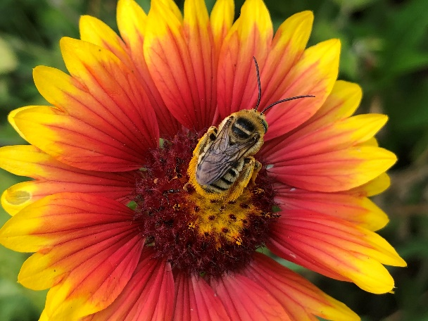

And now for a Nature Moment, from my family’s wildlife-habitat garden to yours. This beautiful creature is a male [Longhorn Bee](https://bugguide.net/node/view/8019) (Tribe Eucerini), shown here on a [Firewheel](https://www.wildflower.org/plants/result.php?id_plant=GAPU) (Gaillardia pulchella), a native prairie flower.  Longhorn Bees get their common name because the males have long antennae—which is frankly an adorable way to describe these bees. :) You can learn more about Longhorn Bees [here](https://nature.mdc.mo.gov/discover-nature/field-guide/longhorn-bees).